Protest poster. Analyzing the visual language and forms of protest images on example of polish manifestations between 2016-2019

Supervisor: dr. Piotr Rypson

1. Introduction to the paper – this one will be written at the end, when I will have my diploma finished and I could summarize its structure
2. Intro – design and politics, polish protest images. Why polish protests and polish protest-posters as the main field to examine?
3. Analysis of the examples
4. Technologies and social media’s role in protest graphics – what is waiting in the future?
5. Summary, conclusion

INTRO:  
  
We can often hear about the death of the poster. We can often stumble upon discussions whether the protest-art and political poster are still relevant? What is the role of the designer on this part of the scene? I would like to analyze the protest art of recent polish manifestations, to examine: 1. If this topic is still relevant? If so, why. 2. In what ways the protest art is done, what visual language it uses? 3. How the social media and technology affects the protest posters and graphics and what might be waiting for them in the future?

1. **Introduction to Protest images**
   1. Protest scene as a field of numerous elements

A designer, Mike Monteiro, during his speech *How to fight fascism[1]*, asked his audience: “What do you wanna talk about ­­– design or politics?” The audience remained silent for the ‘design’ but applaued the ‘politics’. After a moment of silence, Monteiro added: “It was a trick-question – design is always political.” He later explains, that every work-involved decision a human is making, is a political decision[2] ­– and since design is labour, it is political. “Design is mainly understood as the activity of producing more or less useful artefacts, but not necessarily as a political activity. The design of an artefact, however, is always also a political decision about how people should live, communicate or behave. Furthermore, design can be used as a political instrument in the form of activism, or as a medium to discuss and dream about possible or better futures”[3].   
 Therefore, every design practice is a political one – whether it is designing a chair or a book. I believe that a designer is always making a political statement (even if an unconscious one), but the most interesting field for me is when the design, already a political action, is used for the political purposes. The same way as we design a chair, we design a political campaign, a war or a protest. In today’s world, when the participation into different areas of public sphere is becoming more approachable, it might become a very important space for the designers to join and surely, a very interesting one to analyze – by looking at types of practices initiated by the designers or kind of visual language they use in their works. Moreover, an important question occurs – is political topic still a “hot” topic for a designer to take on or is it more of an old model, which doesn’t work in a technological self-centered world of social media?   
 However, beside the creator, there is also the second perspective, perspective of the spectator, viewer. The politics for most of us appear as a spectacle. They have a strong performative character[4]; political scene is often referred to as an artistic field of symbols and signs – attributes and props. Stephen Duncombe and Steve Lambert, artists who’ve started a project *The Center for Artistic Activism* (in short: *c4aa*), an online platform on topic of protest art, said in their article *Why Artistic Activism?*: “We may like to think of politics as a purely rational business, where sensible people logically discuss and debate the issues at hand, come to a reasoned decision, and then judiciously act. (…) But as recent developments in cognitive science suggest, humans don’t think and behave this way: we make sense of our world through stories and symbols that frame the information we receive and then act accordingly. The principles governing civic action are more likely to be found in the worlds of popular culture and entertainment, and artistic expression and reception, than in textbooks of political science.”[5] That means, that analyzing visual aspects of protests, looking at the signs and symbol they use, is exactly how most of us “read” those events and try to understand them or at least store them in our memory.

Those elements of protest images can be of many different kinds: starting from images, that we recall from an event, performative actions to banners, badges, t-shirts and posters. There are protest images that are created as an input of the experience (being more of a social phenomenon) – not designed items[6] and elements, that are protest art, produced for the protest purposes[7]. This idea of a complex structure filled with many elements, is growing even stronger in recent years, with the social media influencing the political (and protest) scene. The channels through which we can share our documentation are increasing, hence the number of elements created (for example within the protest), that are spreading and multiplying. To explore such scene, we have to look now in all different directions at the same time and take under consideration number of elements, because the protest doesn’t end in one specific time and place. David Crowley, the curator of 25th Biennale of Poster, mentions this aspect in his essay about new forms of political posters, *Poster Remediated* – he calls it, quoting Eyal Weizman, the “image complexes”. “Eyal Weizman has described the increasingly multitudinous ways in which events are recorder: ‘We can no longer rely on what is captured in single images’ he writes, ‘but rather on what we call ‘image complexes’: a time-space relation between dozens, sometimes hundreds of images or videos which were generated around incidents from multiple perspectives including ground, air and outer space’.”[8]  
 The question that occurs, is whether it is meaningful to explore this complex web of components? I believe that analyzing what we create and how, using what means and visual language, can tell us a lot about our functioning in the society and in the arts world. “Our modern political terrain is a highly mediated land-scape of signs and symbols, story and spectacle. To operate successful on this cultural topography we need to observe, analyze and respond creatively”[9] – say already mentioned Ducombe and Lambert. I consider this exploration to be an important part of the process of being a creator myself. It helps you to find a way in a crowded and busy world of visuals. It can also answer some questions about the future of form of the protest images – and the role of poster within those.

1.2 On Polish protest images – and is the topic still relevant?

We could argue if analyzing protest posters and other graphics is still relevant in this overstimulated space and already described area of political images. However, recent years proved us, that the world still needs protests, and the protests still need graphics. “The more the social-political sphere is changing for worse, the better the protest art is doing”[10] says Alek Epstein in his article *Who needs protest art?.* Right now, with a lot of tensions in society it is a great time for the rebellion and social disapproval, a lot of fuel for socially-involved artists: Trump on the western side for American citizens, strong shift towards nationalism and even more radical movements, climate change and refugee crisis as global issues, creating numerous tensions and social injustice.

That’s partly the reason why I am choosing to analyze the protest scene of recent years – we can find a lot of examples to justify the fact, that the correspondence between design and politics, is a live and topical subject. Those examples can be found not only in the art scene itself, but in the curatorical, museum scene – which proves, that maybe analyzing and classifying the protest images is just as important now, as creating them. Just to name a few of the international examples: *Hope to Nope: Graphics and Politics 2008-18* (Design Musem, London 2018), which discovers “how graphic design and technology have played a pivotal role in dictating and reacting to the major political moments of our times”[11]; *Disobedient Object* (Victoria and Albert Museum, London 2017), which examined a “powerful role of objects in movements for social change”[12]. A more local example of the fascination with this subject could be a polish exhibition held in 2016th in Warsaw’s Poster Museum for the 25th Biennale of Poster in Warsaw, *Poster – remediation*[13]. It focused on the poster and the transformation of its form and media, but with an obvious accent on its political and social meaning, as well as with a vigilant observation of different areas of graphics: facebook and twitter posts, stickers etc.   
 The polish political scene of images and graphics is as interesting to analyze, as the global one. Especially with the recent political transformation towards right-wing party, that engendered numerous civil actions and protests, giving a new life to social engagement. The artwork of polish protests and practices connected with them has been changing for past few years and shifting towards very local and collective character. From a very wide range of events offering different artistic activities of creating hand-made protest art, to a very strong role of young designers and artists joining the protesting mass and creating special internet platforms; protest symbols moving outside of the manifestation zone into our every-day life, with graffiti, stickers, pins, badges or t-shirts, but also on our social media feed[14].   
 Although some of those practices might be new (or reborn), the presence and role of protest image and symbols of huge social impact has been an indispensable element of polish political scene. Poland is very easily identified with political resistance and active involvement of society in its political shape. The country’s image abroad is often defined by visual symbols, that influenced it: “Poland, the poster child of peaceful 1989/1990 transitions in Eastern Europe”[15]. Its political history is associated with visual signs and revolutionary images – the most famous ones being the Solidarity sign and political posters such as *W samo południe*. They are the components building our creative memory and national art history.

1.3 Why protest posters?

Possibly, poster places as one of the most important forms in history of Polish political art. Poster’s role in politics is known to be immeasurable in general, especially in Poland, which experienced a strong influence of war posters, as well as soviet-propaganda graphics. Why this graphical form plays such an important role? “The pictures have a very strong persuasive power, which often fits into perceptual schemes independently from our free will”[16] – says Krzysztof T. Konecki in the introduction to *Socjologia wizualna w praktyce. Plakat jako narzędzie propagandy*, which studies poster as a propaganda’s tool from the point of view of sociologists. Although the book analyzes the propaganda-poster, quite the opposite of protest-poster, the psychological mechanisms behind reading the poster by an audience and hence its role, remain the same.

“Poster affects our emotions, it should awake and uphold them and, eventually, encourage to action.”[17] If we accept this description, then it is an obvious answer, why posters play such a strong role in manifestations. Besides that, according to Ferenc, Dymarczyk and Chomczyński (in the same publication), posters are a free of charge form of art, which makes it egalitarian for society and it creates a meaning, which is easy to decode regardless viewer’s educational level or their perceptional skills[18]. Furthermore, the picture remains in viewer’s memory longer than a spoken or written word. Last but not least, we mustn’t forget about the economical aspect of the poster – it is a reproducible form[19], quick and easy to be spread around the city. Therefore, poster’s accessibility means not only on a picture, that is easy to interpret by a mass, but an efficient production.

L.A. Kauffman in her book *How to Read a Protest: The Art of Organizing and Resistance* puts stress on the poster’s and signs’ role already in the introduction to the book, explaining one of the functions, which may not be that obvious, but empirically, is one of the most important ones, since it helps us to interpret the context of a given sign. She says: “An excellent place to begin is by looking carefully at the signs that demonstrators carry. After all, signs are often the first thing that tells you a protest is a protest and not some other large assemble of people. (…) People carry signs to communicate and to affiliate – to tell the broader public how they feel and what they want, and to show they identify with a movement or a group. (…) Big protest, especially, almost always feature signs or banners, and these offer rich clues to what’s really going on: how the demonstration came together, what kind of movement it grew out of, who sponsored it and what impact it might have.”[20] The broader public in this case might mean not only the people, that surround the given protest, but also the global audience. Margaret Cubbage, the curator of mentioned before *Hope to Nope* exhibition, explains the usage of signs and posters– protestors use them not only to be recognized by others as “one of them”; they are “aware there’s an audience out there on YouTube or Twitter or Instagram”.[21]A protest poster then can tell you a lot not only from the artistic perspective, but paint a more complex picture of social and political dependences.

Simultaneously, something equally interesting is happening with the elements of protest poster – there are many examples, when the symbols, graphic units travel to different locations, out of their original context – they appear on Instagram, textiles (merchandise), Facebook posts, smartphone emoticons[22] or even media; and they evolve to be the main symbol of the given protest, through which people can recognize it.

I’m interested in how given protests are designed, is there an aesthetic coherent idea behind them; what kind of emotions these designs play on, and what is the message they are sending to the viewer through it means? Could we somehow group them and finally, what their future is going to look like?

1. **Analysis**

2.1 Method.

As already mentioned before, a political scene is viewed as an artistic stage full of symbols. Hence, I will try to look at this field as wide as possible – with focusing on the poster (or what I also call protest images and graphics) as the main point of the protests, that I will examine, but additionally, taking under consideration other artefacts, that are accompanying it or the ones that are a trace, remnant of the poster’s symbol.

I will analyze their structure, composition, colors and typography they use, slogans they create, the symbols they use – and what kind of emotions they evoke. As well as how specific emotions behind a described protest affect the images, that are produced for it or as its effect. The second part will be devoted to the transformation of the protest images (focusing on the examples analyzed in the first part) in the era of technology and internet – their form, meanings, surfaces they appear on, the route of their “existence”.

I will be describing most significant protest images of years 2015–2019, representing the four years of PiS as a ruling party. The year of 2015 drastically changed Polish political scene, which later evoked in intense protests due to new reforms – among the most noteworthy ones is Women’s Strike in 2019. The same protest opens an article at *Krytyka Polityczna & Eruopean Alternatives* called *An illustrated guide to the symbols of Polish protests[23]*, which lists one of the most important visual signs of polish politics of recent years. The second example will be the protests against changes in the polish’ court system, with *Konstytucja* poster as a leader of this movement. The polish nationalist’s protests and their posters also function as an interesting example, with their opposition against LGBTQ movement as well. The *Młodzieżowy Strajk Klimatyczny* (English: *Fridays for Future*) or the Teacher’s Strike serves also as a fascinating case of protests of recent years, however I believe they provide more of a universal iconography and visual language, rather than a one, that could be immediately connected to a polish protest.

2.2 Women’s Strikes and Black Protest

The polish Nationwide Women’s Strike was born to life in October 2016 in response to polish government’s law restrictions. The Women’s Strike initiative held a lot of manifestations, often known under the name of Black Protest. In contrary to the Women’s March in U.S.A, that took place only few months after the polish one (concerning Donald Trump’s presidency) and was often described as “a sea of pink”[24], the polish Black Protest (as the name suggests) was quite black. With similar motivation behind both events, what in U.S.A looked like a manifestation of femininity and demonstration of ‘girl power’, in Poland consisted more of anger and sadness (taking in consideration the weather as well – it was raining that day) and resembled a funeral or declaration of war (Anna Kiełbiewska, who I mention later on, attributes similar connotations to this event[25]). The colors used in those two protests are also a part of their design – they set emotional character and political agenda of the event immediately.

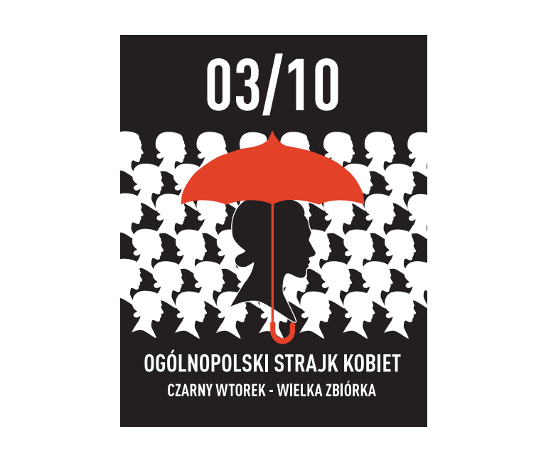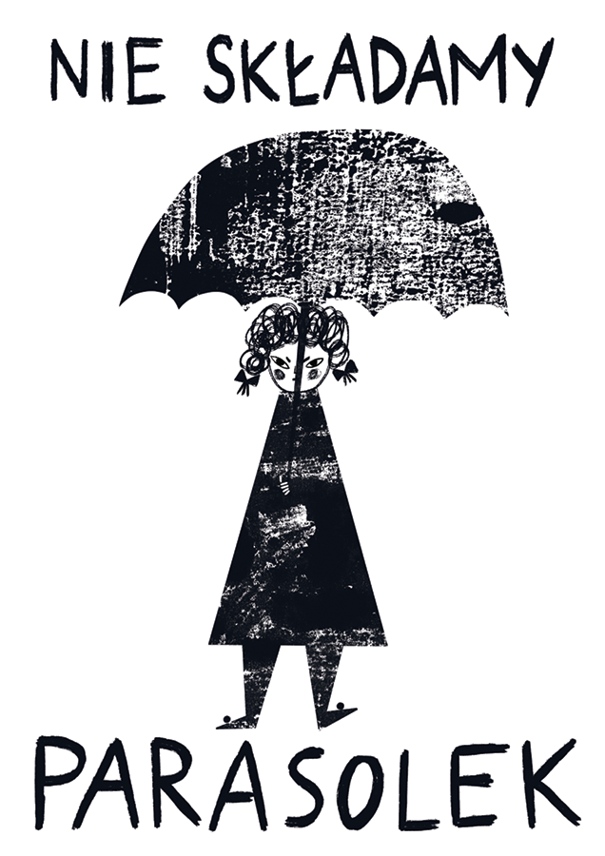

Gosia Herba for *Pogotowie Graficzne* Post from Women’s Strike on social media

Due to the weather conditions that day, the umbrellas, became the attribute of the protesters and later on, a visual signage of the whole protest. They became such a strong feature, that they later appeared as a repeated slogan on banners and posters made by designers; umbrella was even implemented into the logo of the Women’s Strike for the purpose of later manifestations.

In this case we can observe an artefact, that travels from the protest street to the poster’s surface and becomes an important element of the visual language of the whole Black Protest. Something that started off as a regular object, became a prop with a metaphorical meaning and an icon, which if implemented into design, quickly resemblances the Black Protest. It serves both as a symbol – of resistance, anger, inaccessibility of women’s bodies for the government; and as a “souvenir” recalling the event in our memory.

The protest posters, that were created for the Women’s Strikes are aesthetically rather coherent. What describes all of them indubitable, is their expressive and emotive character. They often use symbols and images of strong emotional meaning, mainly anger: clenched fists, middle fingers, angry faces, screams. It’s not surprising, when we consider the motivation and reasons behind this protest ­– women, who feel not visible and ignored, want to reclaim their voice and bring back to the political debate “the language of rights and emotions, an important tool in the debate around abortion”[26], as said Elżbieta Korolczuk in her analysis of the origins of the polish Black Protest.

Those posters share not only the expressiveness, but also the images used (practically always in the center of the composition). The images very repeatedly include parts of women’s bodies, often uterus and legs (an image of a uterus showing a middle finger was one of the most popular symbols of the protest), that in their character or by some sort of transformation, communicate a new meaning. The anthropomorphization of those elements, as Anna Myśliwska points in her book *Polska Współczesna Ikonosfera Narodowa*, is a way for “reviving and enhancing the scheme of the visual composition.”[27] With a changed shape or new angle, the body parts gain new senses – for instance, rotated and spreaded legs become a hand with a “V” sign, reminding of liberty symbol, and in Poland famous Solidarity symbol (a symbol which Myśliwska states to be one of our main national signs[28]); but the V can also stand for Vagina. However, a great number of posters do not necessarily use symbolic presentation (przedstawienie), but they base the poster’s idea on an image with a direct meaning – perhaps, in that case women do not want to disguise the anger in a symbolic form, but present it more literally.

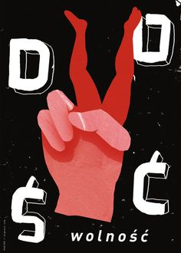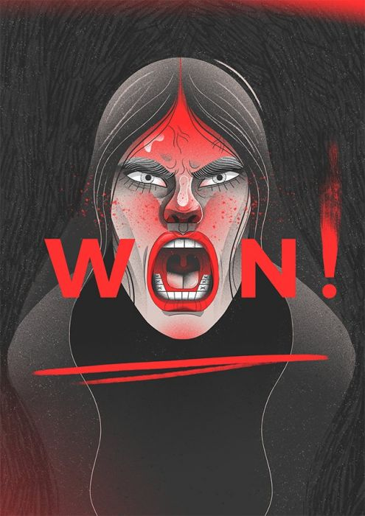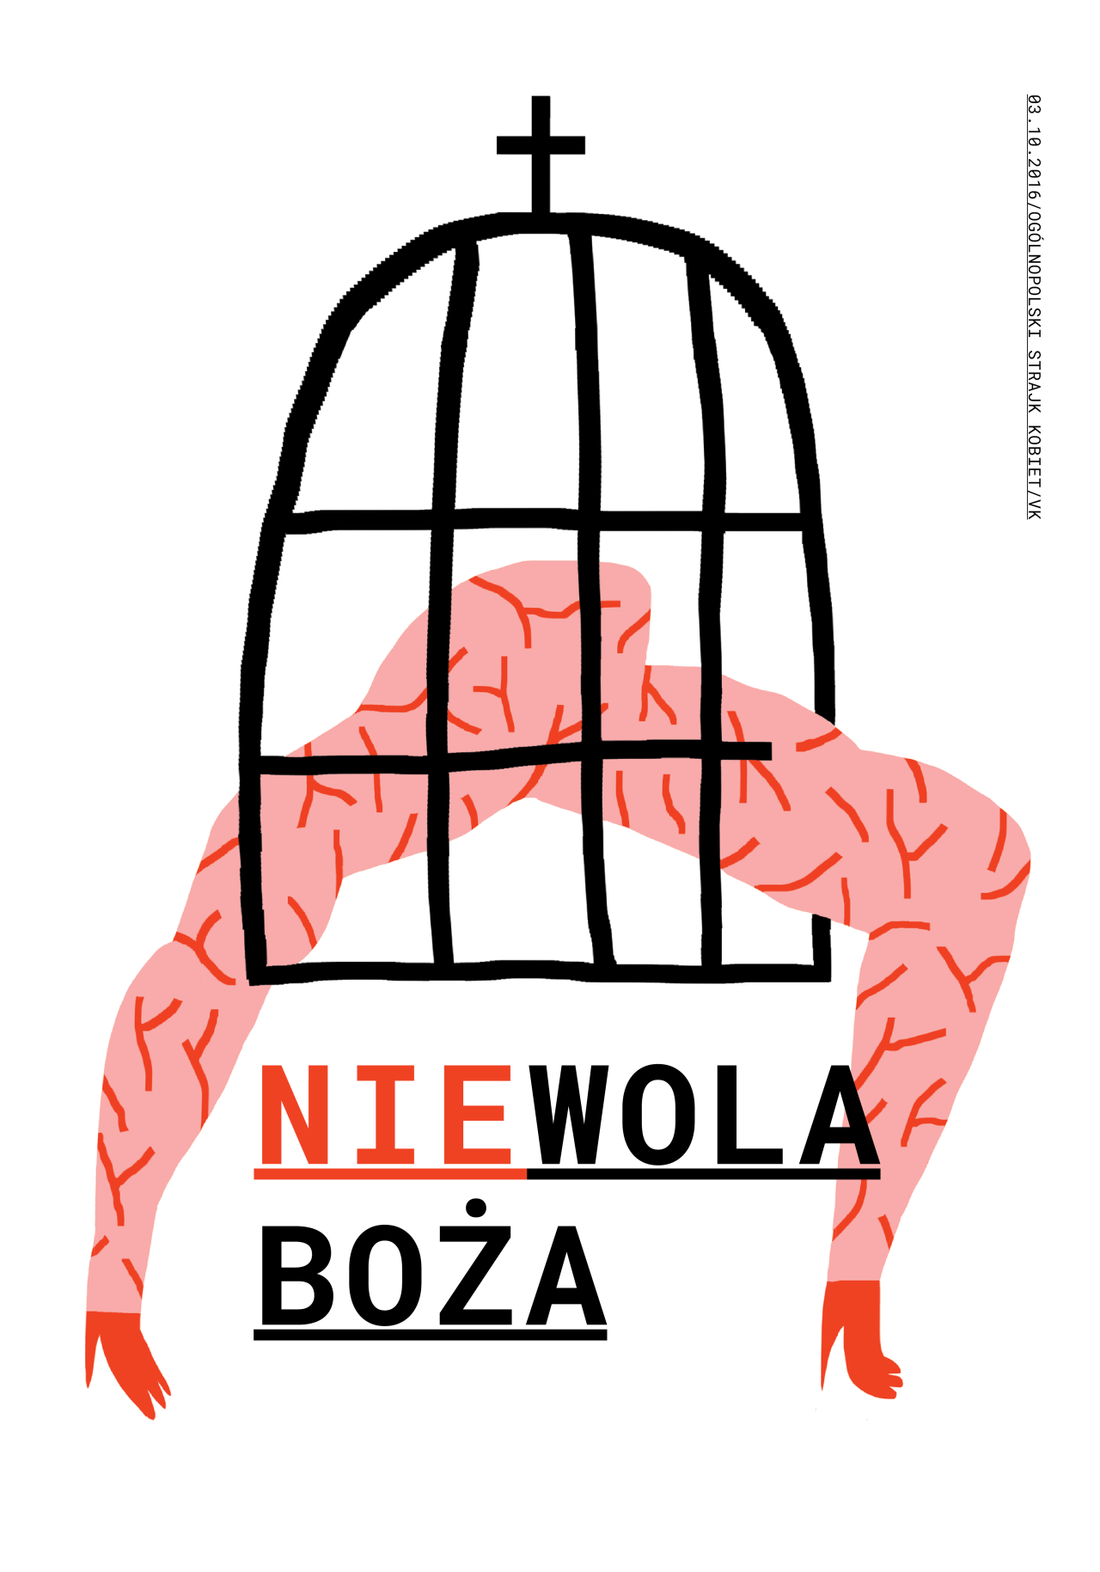

These graphics use feelings as their visual language and they assume the posters will awake the same emotion in viewer. What also is a shared feature, are the colors – the majority of those posters use: red, white and black; rarely appears pink. Red and white of course instantly connects us to Polish flag (za Myśliwską another of few national symbols[29]) placing us in our local context; black serves as a signifier of the Black Protest event, but also it associates with war, anger, mourning – it provides a more serious tone for something, that otherwise could be perceived as light and “girly”. Anna Kiełbiewska in *Rhetoric of Social Movement*, an article analyzing the language and slogans of Black Protests, describes the usage of black color during those protests, saying: “The black, which connotations in our culture are death and grief, has been used by protesters to create a coherent visual identification.”[30] She also mentions the black color as a dominant in different fields, like clothes and make-up (black stripes on faces).

The dominating image for the Women’s Strike (alongside the already mentioned “angry uterus”) was the logo – a shilouette of woman’s face, created by Ola Jasionowska. It became a recognizable symbol of the whole event and thanks to its universality it was easily adapted – both by the authors themselves for different protests, as well as in the internet space by new designers (the latter one I discuss more in the chapter devoted to the role of the internet in protest images). The minimalistic appearance allows the image to be adjusted for different political situations: the LGBTQ parades or anti-facists manifestations. The image still strongly connects with Women’ Strike, becoming then an official and literal message – a support of one protest towards the other.



<https://www.instagram.com/p/B0qvBaKnAIC/>

2.3 Konstytucja poster – protests against judicial reforms

Another interesting example of the image- and symbol-based scene of Polish protests is the *Free Courts* protests and the Konstytucja poster as its graphical representative. The protests against judicial reforms in Poland, which began in 2017, had some performative and symbolic actions connected to it. *Krytyka Polityczna* highlights candles as a distinguishing symbol[31] – they were brought few times in different occasions and with different meaning (balancing between hope and votive, mourning character of a candle), white roses are also mentioned as a distinguished symbol in *Protest’s formulas, protest’s tools* in Pismo Widok[32].

From the visual examination, we can observe that there were a lot of already existing symbols used during the manifestations – a lot of polish and UE flags. However, the most representative and widespread sign of the protests became the Konstytucja poster, mentioned in the *An illustrated guide to the symbols of Polish protests* as well – “the poster became a symbol of struggle in defense of constitutionalism, rule of law, and the independence of the judiciary”[33]. What’s interesting is the fact that the poster wasn’t created for the protest itself, but for the internet project *Demokracja Ilustrowana*[34] and only later adapted as a protest poster for the manifestations against judicial reforms.

From the aesthetical point of view, the poster is very simple – it has a clear composition and it works mostly through typography and colors. A very clean and minimalistic appeal stands for a very official and serious character of the protest itself, which was opposed to formal changes in law. The “Konstytucja” word is written in black, except for two syllables – “ty” (meaning “you” in polish) written in white and “ja” (meaning “me”) and the whole word is separated into 3 parts or “sliced / butchered.”[35] Jan Kubik, an anthropologist studying symbols of power, explained how the posters is read – “the Constitution is not an abstract thing, “a sort of a small book” (…) but a document that is vitally important to you and me, as it has something to say about us as individuals and as a collective. We are “in” the Constitution; there is a dimension of our relationship that needs to be regulated by this document and we are all for it, enthusiastically.”[36]

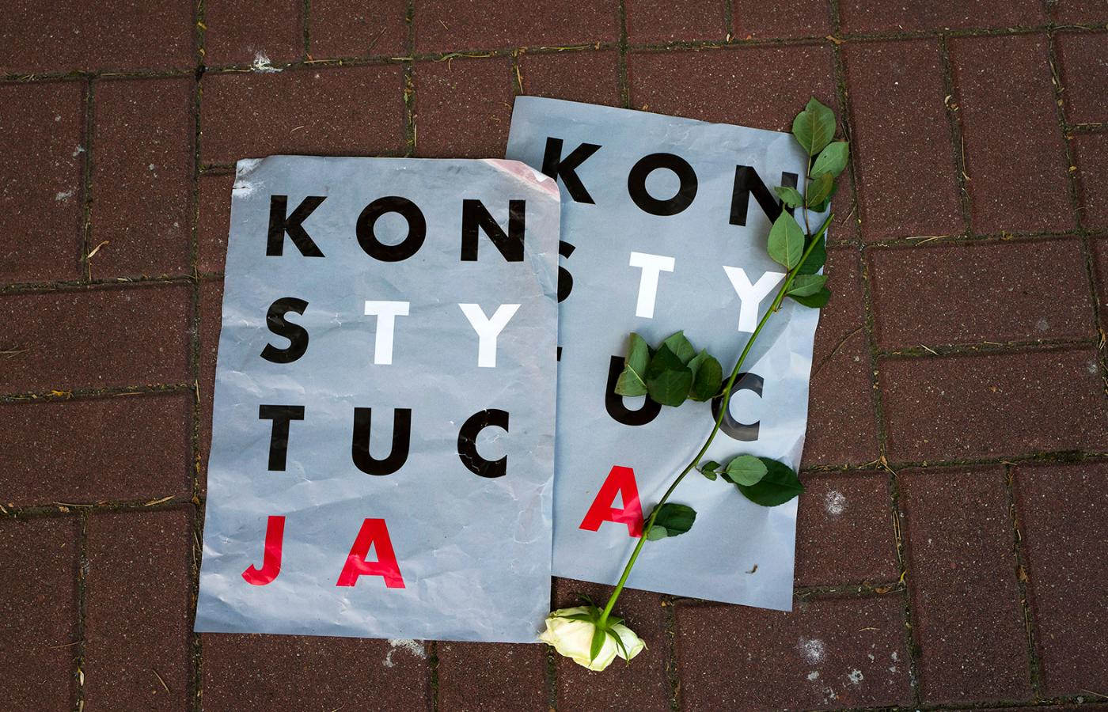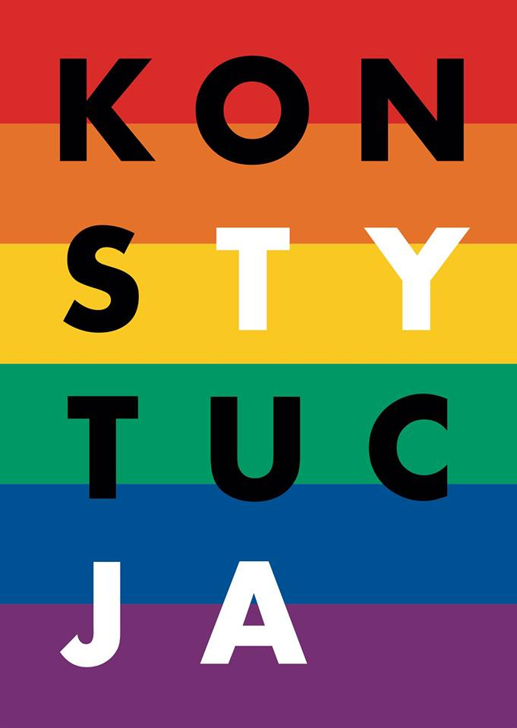

Luka Ryski, Konstytucja

This message strikes the viewer immediately and very directly – to quote Mateusz Halawa, responsible for the distribution of the poster, “the key idea is very inclusive.”[37] During the polish government’s social workshops, he underlined, that the Konstytucja poster created an „affective community and the subject of protest, the Constitution and law – what appeared as very cold and distant, became closer to people, something worth fighting for”. Moreover, this rather simple design and inclusive meaning, allows the protestors to easy adapt it for the individual purposes (the same case as we observed with the Women’s Strike’s logo) – whether this means changing the background and colors (for instance for a rainbow, a LGBTQ’s symbol for the Stonewall Group).

Konstytucja poster became such a strong symbol of the protest, that is hard to analyze different images that appeared as being equal representatives – a prove to that are photos presenting masses of people holding Konstytucja poster, which makes it hard to distinguish different graphics. This might be closer to the idea of E.W of ‘image complexes’, in which we must study lots of photos and videos of specific event, to understand its character[38]. However, *Pogotowie Graficzne* can once again serve as an interesting archive of posters for this protest as well. If we examine the images presented there, we can immediately notice the usage of polish iconography. The national symbols are not limited to the color use (national flag), but they are adapting different symbols – the eagle from the emblem or the shape of Poland. Some of them use the antropomorphization (for instance a hurt shape of Poland with a wound), which might serve as an interesting case – Myśliwska in her *Polska Współczesna Ikonosfera Narodowa* admits that “polish flag and the outline of borders are rarely being anthropomorphized.”[39]



Jacek Rudzki, Wolne sądy! Ada Kosterkiewicz, Palin am się Polska Kaisu Almonkari, Sól

2.4 Right-wing protest graphics

From my observation, those protests remain as one of the strongest channels of symbols and icons, that affected our national sphere and actually joined and broadened our visual language in recent years. I was wondering, where does the strong dominance of these leftist graphics in my research come from – when exploring the current political symbols and images I couldn’t think of solid conservative examples. Initially, I assumed it was a political bias and lack of knowledge. However, shortly after I’ve came to a quite obvious conclusion, that this depends on the current political context – throughout last years the ruling party has been a right-wing, conservative one, its supporters are less often protesting than the left-wing followers. Right-wing graphics are strong in the field of daily national images – numbers of shops with national clothing are opening and spins on national symbols are being spread online. The protest images as self are less relevant for the conservatives, who are privileged in present situation.

Nonetheless, there are some strong current examples – they illustrate a certain usage of visual language, rather than providing us with memorable symbols or images. One practice I’ve noticed is that of re-using the symbol of the political opponent, which I observed when it comes to LGBT’s symbol – rainbow[40]. As a form of counterdemonstrations, the anti-LGBT community presented posters using the rainbow symbol as a sing of upcoming storm from which the family hides under an umbrella[41]. The images were spread as posters across the towns, as well as internet graphics on the social media – shared by parliament members as well. Another form of visual retaliation are the anti-LGBT stickers, using symbol of a crossed-out rainbow, that were destined to be sold with polish newspapers.

The already mentioned Women’s Strike resulted in interesting conservative visual practices as well. When cities were full of umbrellas and designed posters on topic of women’s rights and abortion laws, the supporters of pro-life movement spread across public spheres a much more literal imagery – posters and car-banners with photos of fetus and large bolded typography, making it impossible for the viewer to avoid it. Its warning-like character and drastic photos (suggesting a realism to them) are on opposite side of a political images, shouting the opinions and affecting its viewer with fear, rather than asking questions or being accessible. When examining the graphics from Independency Marches or posters by Młodzież Wszechpolska, we can see some similarities – frequent usage of photographies, big and bolded typography. The most popular graphic poster I’ve found was one of Independency March 2019 – a fist holding rosary. The image and slogan take the whole space of the poster, stressing the dominancy and supremacy of patriots, rather than being a well-designed poster.

1. **Present and future form – social media and technology’s impact on protest images**

Probably the most interesting aspect right now to investigate is the impact and role of social media and technology on protest graphics (including polish protest images). They affected not only protest images but also the protest itself – to quote Liz McQuiston, the author of *Graphic Agitation 2*, “the internet revolutionized the organization, accessibility and information dissemination of protest movements, giving birth to the global protest network.”[42] As she later states, it made a very direct communication possible and created numbers of new inventions (like chatrooms, active networks etc.) – “such possibilities greatly expanded the diversity of protest methods. Activism could now take the virtual forms of online ‘zines’, dedicated websites, text messaging, viruses, spoof websites and hackings.”[43]

Those inventions influenced the protest images as well, giving them possibilities of new narratives (for example with animated posters), while social media helped distributing the protest design in the worldwide net, allowing others to easily participate in the protest without being there physically – by sharing the design, but also allowing them to join the conversation by remaking the art in their own style. It is also a great platform for sustaining and encouraging the collectiveness and unity of social groups behind the protests. Technology and internet affected also another very important element of the modern, XXIst century poster – its language, by creating a new globalized iconography of images.[44] For this part I would like to examine how the new media and technologies affected the recent polish protest graphics from the previous analysis and try to speculate what might happen to protest posters in future.

3.1 What happens with the image in the internet and social media space?

The discussion around the destination place for the poster has been a vivid part of the academic and pop-cultural discourse – whether the poster belongs to the museums or streets. In recent years, with the poster’s shift from museums/streets to our phone screens, new alternative answer appeared – the internet. This is a perfect place for the growth of protest art and artistic activism, as is stated by the founders of Center for Artistic Acitvism: “Artistic activism (…) is also well suited for an age of cell phone cameras and social networks. People don’t share policy papers, they share things that move them.”[45]

Social media and online platforms affect both form and accessibility of the protest art. On one hand, they repeat the collectiveness of the protest with online forums, Facebook planning events, sharing each other posts, using the same hashtag or creating online spaces for sharing protest images (example: Pogotowie Graficzne). On the other hand, they create a space for rise of individual artistry – with remixing the protest art or creating your own, which easily can go viral and become a recognizable symbol of an existing protest or a political call to action (example: Je suis charlie). They change the face of artistic activism in a way, that was never accessible before.

Internet and social media provide a great number of tools, that can be used to create protest art and a political content – from emoticons, through memes to Instagram feeds. They all offer an important quality – freedom of speech. The viral and rapid character of social media allows political artistic pieces to spread worldwide without danger of being censored or taken down by authorities – they cannot be silenced or taken down. It is not only a matter of censorship, but also safety – “internet’s anonymity afforded by the Internet sometimes provides security”[46] says David Crowley, when explaining how the protests of 2010 in Saudi Arabia popularized the electronical poster, which gave its creator protection.

Protest image’s egalitarian character relies not only on already mentioned ‘freedom of speech’ – meaning content, topic or character of the graphic, but on its possibility of self-publishing. McQuiston says, that “the developing technologies also smashed remaining barriers between professional and amateur modes of production and publishing.”[47] It’s not required to be a specialized designer to post a graphic. Hence, the publishing itself can be perceived as democratic, and so is sharing. The image, spread within the internet, is prone to (re)sharing, reusing, remixing – making it accessible for everyone to take a stand in a political debate. Crowley, repeating the words of Hito Steyerl, points to the democratic character of such actions – “its optical connections – collective editing, file sharing, or grassroots distribution circuits – reveal erratic and coincidental links between producers everywhere, which simultaneously constitute dispered audiences.”[48]

Understandably, the internet (and social media that come with it) consists of disadvantages as well. Though from the core idea itself, it is shaped as a democratic and egalitarian space, it doesn’t fulfill this idea completely. Firstly, it is run by influencial wealthy companies, that can manipulate its content. Secondly, it is not egalitarian in a way, that it requires owning a technological device to be a part of the society within internet space. Thirdly, the idea of sharing images, which Steyerl describes more as uniting, can be perceived contrarily. As Marcin Stachowicz in *Vulnerable Bodies. On the Visibility of Political Action* in Pismo Widok points out, “(…) this ‘visual activism’ is pilloried by critics of practices combining aesthetics and politics; in their opinion, aesthetic activity—including generating representation—supposedly draws attention away from practical objectives.”[49] Indeed, the flood of protest and political graphics on social media might be just an empty signal, a dead end – a false visual manifestation, an action more esthetical than political. However, when taking under consideration the number of protests and protesters, the problem, even if existing, doesn’t seem to be an obstacle for the real manifestations. Therefore, we shouldn’t study the social media as an opponent for the protest, an untrue reflection, but a parallel phenomenon in a digital era – “the growing ‘power’ of representation cannot, however, be completely omitted in analyses, especially given the fact that it is often the appearance and spread of suggestive imagery that triggers political mobilization”[50] says Stachowicz.

Whether we consider internet to be egalitarian or not, the processes related to images being shared, are existing. The shared images, which are displayed for reusing and remixing them, change the idea behind art/design piece itself and its authorship. Protest art especially is one of the examples, that embodies a new idea of post-art – Sebastian Cichocki, a sociologist and art critique, says, that arts created for manifestations and protests lack a specific authorship, its character is collective and spreaded[51]. The visual symbols and signage stream from protests into different spaces and media; they are dynamic and variable (?), gaining different meanings depending on place; their main purpose is to distribute an idea, rather than a certain artist’s name. It can lead to numbers of derivatives of different kinds – as Tomasz Ferenc writes in context of war posters in *War, image, propaganda*, derivatives can be used in “propaganda purposes (ideological manipulation), commercial purposes (economical manipulation) or subversive (actions of underground, subcultural, antisystem or quizzical character).”[52] Therefore we shouldn’t perceive the image’s meaning deriving exclusively from its visual side or from its original context, but from the context it is placed in the specific moment.

The reused image can also repeat the exact function of the original graphic (or following Ferenc, its purpose) but with newly adapted cultural character. As an example, we can take a look at the logo by Ola Jasionowska, one of the symbols of the already discussed earlier, Polish Women’s Strike ­– the silhouette of a woman’s face. The image became viral in the social media and grew to be an icon of the political women rebellion. Soon it reappeared as a symbol for manifestations in different countries, with distinctive elements added to characterize the specific country – for the Paraguay’s version the girl’s hair is braided, for the American one the woman is Afro-American. Jasionowska admits, that although for the graphic designer someone else recreating your work is not usually a pleasant situation, however, under these specific circumstances, it is flattering, proving that the image fulfills its role[53]. The image then becomes solely a social and political message, rather than an artistic and esthetical possession, realizing its protest-like function – being a part of the public domain or street sphere, rather than private or museum space.[54]

As I’ve already mentioned, for the protest art, the aspect of accessibility and role of the image for the society is maybe the most important one. Polish internet spaces like *Pogotowie Graficzne*[55] (English: Graphic Emergency), a platform from which anyone can download and print a poster by polish designers, bring the political issues closer to the viewer[56]. At the same time, they make protest art easy to access – all of the posters there are created and available for free. *Pogotwie Graficzne* has already supported not only the Women’s Strike (the event, that initiated creation of the platform), but also the Judical reform protests, Teacher’s Strike or the Elections of 2019. They serve rather as a space rising the political agitation within society, than a simple provider of polish designs.

Initiatives like this succeed to transform street landscape during a protest – the self-made banners (usually with hand-written slogans) are still the dominant group, but we can observe a rise of the graphic designed posters, many of which come from those online platforms. As a great example of that, we can examine the documentations of Women’s Strike’s[57] – where lots of graphics came from the *Pogotowie* Graficzne. It affected not only the visual side of the protest; as Agata Araszkiewicz points out in the Magazyn Szum’s article about correlation of recent female rebellion and art, it also affected the morals of the protesters ­– “the protesting women in every region of the country were supported by the female poster strike emergency (<http://pogotowie.tumblr.com/)>. Thereby women gained a formal, artistic reinforcement of their politcal visual language – the initiative became very popular and art created by women – as a fulfillment of feminist ‘artivism’ – gained a new political dimension.”[58]

The Konstytucja poster, although not created for the protester’s needs purposely, comes from the Internet platform as well – *Demokracja Ilustrowana[59]*. This might serve as an interesting example of the inclusive character of the image–Internet relation – it was an ‘average’ website’s user that decided to print the poster herself, take it for the manifestation against judicial reform and give it a character of protest graphic (only after seeing it on the protest, Luka Rayski, the author of the poster, decided to multi-print it and distribute as a protest poster[60]).



<https://www.instagram.com/p/BgvP1m2Hckn/> <https://www.instagram.com/p/BgwHRlSA72B/>

3.2 Transgression of the form – new media, new surfaces, new roles

Poster and protest images can take on different forms and transport itself to different surfaces. Surfaces differ a lot – from, already existing since French Suffragettes carried posters on themselves, human bodies (transforming them into, what Crowley calls, ‘human billboards’[61] or “centaurs: half-human, half-transparents”[62] as called by Michael Taussig, American anthropologist), to flyers, stickers, t-shirts or reprints in newspapers.

The Konstytucja poster is a great example of the flexibility of the image – after becoming a recognized symbol, the poster started appearing in multiple different forms and places. “Gazeta Wyborcza printed it on its back-cover, NGOs helped spread it to tram, bus and subway screens, and downloads have gone into the thousands”[63] – as well as cups, clothing, Christmas bombshells. Many of the objects, that became the new “canvas” for the image, are merchandise, questioning the protest-like (and moral) character of the image (it should be noted, that not only the protest images can become a product, but the protest itself can become commodified[64]). This can be recognized as another type of politcal graphics’ transgression – derivative of commercial purpose (meaning a graphic’s merchandise).

Although it might be questionable to let the protest images become objects of consumption, they can be also used to popularize the protest or as an attribute for political performances – as was in the case of Konstytucja t-shirts. The t-shirts were put by protesters on famous polish statues (among them statues of famous Poles) – creating a worldwide political action. The t-shirts can also serve as a symbol of the protest and unity of the protestors, a distinguishing badge, what Liz McQuain calls as “a mark of support and identification.”[65] I believe this expands the protest’s ‘place and time’ – wearing a t-shirt allows you to manifest your opinion not necessarily during a strictly political situation. A photo of a person wearing a “protest t-shirt” becomes instantly a complete picture with a direct message – something what we could call, once again quoting Crowley’s term, a “human billboard”. Probably, the picture of that kind, that is saturated with symbols the most, is a photo of Lech Wałęsa wearing Konstytucja t-shirt (or rather a whole series of his pictures wearing the t-shirt to specific events, such as balloting a vote or simply buying shoes) shared on his social media. Wałęsa – a living symbol of Solidarność himself, a visual representation and sign of Poland, and Konstytucja t-shirt – a symbol of Free Courts protests and of protest image, that derived from the heritage of polish iconography. This shows once again the impact of this poster on the polish political scene.

We easily see that the mobility of poster (or an element taken from it) isn’t a new phenomenon. However, with the rise of technology, the possibilities (as well as threats, that derive from them) multiply and go beyond pins and t-shirts. With the escalation of electronical forms and communication, the topic of ‘death of poster’ (and concerns regarding the future of this area of graphic design) increased – as David Crowley points out in his essay *The poster remediated*. However, poster did not become replaced by internet. As Crowley later says “it is not that the poster has been killed off by the screen but that poster *effects* have been subsumed into newer media.”[66] Just like any other form of media, poster and images as such had to adapt and embrace idea of the transformation within new medias and new technologies – hence, new forms of posters began to rise in late decades of XXth century and new forms of distribution appeared with the birth of social media in early XXIst century. “This extraordinary mix of low-tech and high-tech, of old and new, has become the hallmark of twenty-first-century protest and will remain its great and enduring strength”[67] says Liz McQuain.

The first significant transformation was from paper to the screen, which certainly changed a lot in perception of the poster. It was no longer a printed piece possible to be found only in specific places (museums, streets); the concepts of colors, texture and size had to be modificated. Moreover, the posters had to face another momentous revolution – the animation. Graphics in internet started coming to life as gifs and with rise of AR (and VR) technologies, even the printed poster became exposed to being animated. In recent years we can observe an increase of what we can call, using a term by a Swiss designer Felix Pfaellie, “a moving poster”[68]. Later, the topic has been picked up by another Swiss designer, Josh Schaub. On his website devoted to the subject, the “moving poster” is described as following: “the moving poster is positioned between the static poster and the moving film. The moving poster offers a wide range of static, dynamic and even filmic examples.”[69] Schaub later presents us different types of animations, showing how the dynamics can vary: there are moving posters without position change, therefore remaining very close to the traditional poster, posters that are being broken into numerous formats, posters with a single movement of one element, and of course posters that are a time-lapse without beginning or an end.

From what we can observe, the moving posters’ narration differs from the original one, however its two main qualities remain the same: portrait form and one simple idea it conveys. However, whereas in the internet’s space the life of a moving poster is justified and very likely to outlast, it is a different topic within our street space. A moving poster can be easily displayed on special electronical screens in the city, but the questions rise with the traditional printed poster, which would require addition of AR technique, hence usage of phone to become a moving poster. The AR technique is often doubted to be a trend, that might disappear.[70] Nonetheless, the moving poster has adapted within the design as its new form and it’s already awaiting another change – as David Crowley states in *Poster –remediations*, “not only do these [interactive] posters come to life on the phone in your hand or on your desktop but they also want to escape the flat surface of the screen.”[71]

The topic so widely discussed within the poster itself, doesn’t seem to adapt to the protest posters that much as to different types of posters. The character of billboards on buildings, street citylights or commercials displayed on bus screens is rather different than that of the protest images. The protest poster itself in its foundations, is a movable and somehow “animated”, meaning brought to life, poster (Barnaby Dicker in her essay *Animated Posters: Business as usual?* in *Poster – remediated* claims, after Louis Althusser, that every poster is animated, once an individual interacts with it[72]). Firstly, it is literally carried and transported by the protesters. Secondly, it is created to be a part of an event (or at least represent a specific event), making it a component of a bigger complexed structure, in which every element of the scenery has its own meaning: voices (shouted slogans) and sounds (drums, screams), specific architecture of the city and the dynamics of group of demonstrating people (this is also mentioned by Crowley – “in their mobility, poster parades bring their messages to setting which are already inscribed with meaning”[73]).

Another interesting aspect, when considering moving or interactive posters, is the idea of “symbol”, a singular sign of the poster – a one that can become a representative mark and identification of the graphic. A moving poster doesn’t neccesarily has one representative image – as explains Piotr Zawojski in *Sztuka obrazu i obrazowania w epoce nowych mediów*, “when we are dealing with a digital image on a screen, we cannot capture a singular image – an image cannot be identified with itself, since its constantly undergoing transformation.”[74] In case of protest graphics I believe that establishing a clear and solid symbol in the image’s composition is crucial for the image to survive in the protest’s landscape.

In my opinion, due to these semiotical and physical determinants, it is quite complicated for protest graphics (the ones that are a part of the protest in public space) to become animated or interactive – they would have to be carried on screens rather than banners or would require an extra external usage of mobile phone and an attention from the viewer (who is often moving as well) long enough to read the entire message.

However, it is obvious, that this doesn’t apply to the protest graphics extracted from the street scene. Firstly, there are lot of protest images created not for the physical protest in the city space, but strictly for the internet space – those can easily be interactive, presented as gifs, animations etc. Secondly, there are the cases, when the actual protest image is presented on the city screens. The Konstytucja poster has been displayed on the electronical screens in Warsaw’s subway; Women’s Strike logo was projected on a stage screen during Pearl Jam’s concert, Crowley mentions the people displaying the *Je sui Charlie* graphic on their smartphones during demonstrations[75] ­– although they weren’t animated, because of their displaying surface, the circumstances would allow them to become “moving posters”.

We have to remember, that electronical screens, even if not providing us an animation, change a lot in perception of the protest poster. It is rather a different emotion to look at four human-sized Konstytucja posters on the subway screen, with artificial white lightning coming from its surface – more elevated and oppressive at the same time, its glass surface can also become an obstacle in decoding the image’s message[76].

Cases like Konstytucja posters displayed in subway, are also interesting considering the screens in subway are the city’s property – it creates another political message, aside from the one implemented in the poster. Moreover, in the modern technological era the electronical city screens might become an object of political battle for public dominance and a premise for manifesting your opinions. This leads us to topic of properties, public and private, legal and illegal art activities. Electronical city screens might serve as an appealing surface for the protestors – Anna Myślińska mentions it in her *Polska Współczesna ikonosfera narodowa*: „recently there are experiments being conducted on the use of interactive media facades, which after receiving signal from mobile or Web can transform from an advertising space into projector, allowing to take over the city space.”[77]

1. **Conclusions**

When it comes to artistic means, some continuity within tradition can be found. As it comes to visual language the current polish protest images are using, the language of an artistic poster, what in our national art history we can call “polish school of poster” is still dominating – with a simple usage of symbols, a limited usage of colors and word-play slogans. As it comes to symbols and iconography – depending on the protest, the posters often have more of an evocative function, conveying emotions, not only a clever message hidden within signs – and therefore use literal picturing and images, rather than symbols. However, the protest iconography is still dominated by national symbols of Poland. The national symbols used within recent protests are both of a positive and negative character – the shape of Poland as an open wound (evoking negative emotions) or sign of Polska Walcząca with female breasts (evoking positive emotions) created for Black Protest; the symbols are often undergoing metamorphosis, transfer to different locations and form. Disputing parties mutually exploit each other symbols and their emotional character. The discourse around our set of symbols and signs increase; with the new social and political topic arising and within a new political climate, the academics wonder, if we should reconsideration our traditional iconography as being well adjusted for the modern times – so proves the discussion in Magazyn Szum, which brought the topic of creating more current symbols and representations to our national visual language.

The growth of social media networks and internet communities, extended the access to protest graphics. The number of professionally designed posters is rising – and they start appearing in big numbers during protests, which beforehand were often dominated by hand-made banners in DIY character. The professional designers are mixing with the amateurs or independent ones – both in the internet or at the city streets. This also changes the idea of authorship and designer – redefining their job and role within the society. The designers are often disclaiming their authorship for the sake of social movement – allowing the protest image to become a political message spread globally.

The fact that protests became an intermedia movement is not recent phenomena. However, with the rise of new technologies and new internet practices, protest graphics are now entering new phase of media transformation. The protest images, which are often the identifying symbols of a given event, allow us to define our protest identity even online, by setting a profile picture with a protest’s image/symbol, as it was in case of black squares during Black Protest[78] or by sharing the protest graphics or our photos with the given symbol (the case of Lech Wałęsa posting pictures of himself wearing the Konstytucja t-shirt).

The easy access to the images allow others to reuse and remix them, and, what we can call, pass them forward – become popular globally. On the other hand, the online activity and presence of the image increase its chances of becoming stolen or reused in different context. These circumstances also popularize a fake-activism[79], which begins and ends solely online, and is not a representation of actual involvement in the protest (or of physical presence during a protest).

Protest images are often transferring, which changes their form – and protest poster is exposed to those transformations as well. The future of poster as such stands before many possibilities – from simple animations and gifs, to AR and VR. Yet, protest poster is few steps behind – while the protest images online are exposed to new media and technologies, protest images on streets are not yet animated or interactive. The interactive aspect however brings perspectives, which might be interesting to reconsider, when thinking of protest posters. The electronical surface itself also present some premising possibility for the protesters. We have to accept the technology as a new form for the poster. Even if the physical determinants of protest image are an obstacle, we have to look at the promises behind animated and interactive poster. They can offer a lot – from using more complexed narratives and perspectives, to provideing viewer with more information by simply linking them to specific websites connected to the protest.

Nonetheless, with all the increasing influence of technology, rises the movement towards “older” analogue techniques and practices ­– many initiatives, in Poland as well, attempt to pass forward and maintain traditional techniques within social and political poster. The self-printed poster-themed zines are created (BIG Poster), the workshops for collective preparation of transparents and banners are becoming more popular (for instance by Extinction Rebellion Polska). I believe those practices won’t disappear; they actually might increase and coexist at the same level as new technologies – with our current political climate, it is often common to return to traditions as opposite to the western model of living.

If we consider the interactive/moving poster as a threat for the traditional poster, a signage of upcoming “death of poster”, the protest poster itself doesn’t have to fear. Even with the increasing intermedia character of the protest, its core power still lays in physical unity, in manifesting bodies (as says Judith Butler[80]) – hence, the printed protest image, being a solid attribute of a protestor, will remain.

1. <https://www.elementtalks.com/articles/100-monteiro/>
2. I would argue that every decision, not only the ones connected with labour, are political
3. http://www.designaspolitics.com/
4. see: Dariusz Kosiński on “democracy of performance”, <http://www.ptbt.e-teatr.pl/files/zjazd2_pdf/Kosi%F1ski_Teatr_demokracji_performatywnej.pdf>
5. <https://c4aa.org/2018/04/why-artistic-activism>
6. A whole issue no. 17 of [*View. Theories and Practices of Visual Culture*](https://www.pismowidok.org/en)has been devoted to Protesting Images, analyzing graphics that are our collective memory of the events: https://www.pismowidok.org/en/archive/2017/17-protesting-images
7. Liz McQuiston lists them all in her Graphic Agitation 2: “graphic formats, including posters, banners, pamphlets, magazines and even cartoons and comics.”, Liz McQuistion, Graphic Agitation 2, 190-191
8. Poster Remediated, p. 81
9. <https://c4aa.org/2018/04/why-artistic-activism>
10. <https://krytykapolityczna.pl/kultura/sztuki-wizualne/komu-potrzebna-jest-sztuka-protestu/>
11. <https://designmuseum.org/exhibitions/hope-to-nope-graphics-and-politics-2008-18>
12. http://www.vam.ac.uk/content/exhibitions/disobedient-objects/
13. <http://www.postermuseum.pl/wystawy/plakat-remediacje-25-miedzynarodowe-biennale-plakatu-w-warszawie-2016,59.html>
14. Maybe my observation is influenced by the fact, that I am growing up and have been an active and conscious participant of polish social-political events for only the last few years – but observations of those kind will always remain subjective.
15. <http://politicalcritique.org/cee/poland/2018/guide-symbols-polish-protests/>
16. Socjologia wizualna w praktyce. Plakat jako narzędzie propagandy, p.8 Krzysztof T. Konecki
17. Socjologia wizualna w praktyce. Plakat jako narzędzie propagandy, p.8 Krzysztof T. Konecki
18. Socjologia wizualna w praktyce. Plakat jako narzędzie propagandy, p. 12, Ferenc, Dymarczyk, Chomczyński
19. <https://www.moma.org/documents/moma_catalogue_1804_300074240.pdf> p.39
20. How to Read a Protest: The Art of Organizing and Resistance, p.4
21. <https://www.itsnicethat.com/articles/design-museum-hope-to-nope-graphics-and-politics-2008-18-exhibition-270318>
22. I won’t have time to dig into all the aspects of graphics of politics and protest, thus I leave this interesting subject of political character of emoticons, to the more eager readers: <https://blog.emojipedia.org/the-resistance-will-be-emojified/?fbclid=IwAR0lOjPOhGzyzGEbKgoVcEvhQFgfZu_JtOzkGCY5QP90FMyhmN9KZhZi250>
23. <http://politicalcritique.org/cee/poland/2018/guide-symbols-polish-protests/>
24. <https://www.pussyhatproject.com/blog/2017/2/17/the-sea-of-pink>
25. <https://www.resrhetorica.com/index.php/RR/article/view/296/158> „Rhetoric of Social Movement”, Anna Kiełbiewska
26. Czarne protesty 2016: skąd się wzięły i czego nas uczą?, Elżbieta Korolczuk <https://www.researchgate.net/profile/Elzbieta_Korolczuk/publication/314724410_Czarne_protesty_2016_skad_sie_wziely_i_czego_nas_ucza/links/58c524fd45851538eb887879/Czarne-protesty-2016-skad-sie-wziely-i-czego-nas-ucza.pdf>
27. Polska współczesna ikonosfera narodowa, p.256
28. Polska współczesna ikonosfera narodowa, p. 263
29. Polska współczesna ikonosfera narodowa, p. 256
30. <https://www.resrhetorica.com/index.php/RR/article/view/296/158> „Rhetoric of Social Movement”, Anna Kiełbiewska
31. <http://politicalcritique.org/cee/poland/2018/guide-symbols-polish-protests/>
32. <http://www.pismowidok.org/pl/archiwum/2017/17-protest-obrazow/formuly-protestu-narzedzia-protestu>
33. ibidem
34. <http://demokracjailustrowana.pl/>
35. <https://contemporarylynx.co.uk/the-latest-polish-posters-addressing-politics?fbclid=IwAR2yGHbo-l9--qIbdryI6-8Mz2I3qG1R_ugZ_lO_eD2rUf0Gr50MxaMmS0Q>
36. https://designobserver.com/feature/a-sign-of-resistance-a-symbol-of-hope/39638
37. https://designobserver.com/feature/a-sign-of-resistance-a-symbol-of-hope/39638
38. The poster remediated, p. 81
39. Polska współczesna ikonosfera narodowa, p. 256
40. the symbol of rainbow is also a symbol appearing in Christianity – the difference is in number of colors used
41. interestingly, the authors (probably unconsciously) used the umbrella, which in the current political climate strongly signifies Black Protest
42. Graphic Agitation 2, p. 7
43. ibidem
44. oto plakat, p. 469
45. https://c4aa.org/2018/04/why-artistic-activism
46. Plakat-remediacje, p. 43
47. Graphci Agitation 2, p. 7
48. Plakat-remediacje, p. 79
49. <http://www.pismowidok.org/en/archive/2017/vulnerable-bodies.-on-the-visibility-of-political-action>
50. <http://www.pismowidok.org/en/archive/2017/vulnerable-bodies.-on-the-visibility-of-political-action>
51. http://wakat.sdk.pl/polityka-protestu-i-performatyka-oporu/
52. Wojna, obraz, propaganda., p. 133, Tomasz Ferenc „I want you” i „We can do it” – szkic do analizy kulturowych transformacji plakatów wojennych
53. <https://www.wysokieobcasy.pl/wysokie-obcasy/7,115167,21461279,autorka-plakatu-ktory-kopiuja-feministki-na-calym-swiecie.html>
54. However, when used for different purposes, it can lead to less enthusiastic conclusion – as it was in example of American protest images, that were copied as t-shirt design by big unrelated companies: https://eyeondesign.aiga.org/ripping-off-the-resistance/
55. <https://pogotowie.tumblr.com/>
56. What’s interesting is the fact, that platforms like this often use social networking websites as their domain (rather than having their own websites) – *Pogotowie Graficzne* is on Tumblr, *Plakaty Zaangażowane* (eng: Posters Involved, Dawid Czajkowski’s project) on Facebook. It once again proves, that universality and possibility of sharing image with others are very important features.
57. Not only the Polish ones – the imgaes traveled to different countries as well
58. <https://magazynszum.pl/kobieca-rebelia-sztuka-i-bunt-spoleczny/> Kobieca rebelia, sztuka I bunt społeczny
59. <http://demokracjailustrowana.pl/>
60. <https://www.polityka.pl/tygodnikpolityka/ludzieistyle/1759850,1,tworca-plakatu-konstytucja-o-sztuce-protestu.read>
61. Graphic Agitation 2, p. 35
62. Michael Taussig, Jestem tak wściekły, że zrobiłem transparent, przeł. Ł. Zaremba, „Widok. Teorie i Praktyki Kultury Wizualnej” 2017, nr 1, <http://pismowidok.org/index.php/one/520/981>, dostęp 10 lutego 2018
63. <https://contemporarylynx.co.uk/the-latest-polish-posters-addressing-politics?fbclid=IwAR2yGHbo-l9--qIbdryI6-8Mz2I3qG1R_ugZ_lO_eD2rUf0Gr50MxaMmS0Q>
64. as it was in a well-known example of Pepsi commercial with Kendall Jenner, that received a global backlash. We can read more about it in: <http://www.pismowidok.org/pl/archiwum/2017/17-protest-obrazow/kruche-ciala-o-widzialnosci-dzialania-politycznego>
65. Graphic Agitations 2, p. 194
66. The poster remediated, p. 25
67. Graphic Agitation 2, p. 198
68. https://eyeondesign.aiga.org/a-new-poster-movement/
69. http://www.themovingposter.com
70. Will Augmented Reality Last in Design Once the Hype Passes? https://eyeondesign.aiga.org/the-designers-shaping-ars-present-and-future/
71. Plakat-remediacje, p. 21
72. Plakat-remiediacja, Animated Posters, p. 105
73. Plakat-remediacje, p. 35
74. Piotr Zawojski in *Sztuka obrazu i obrazowania w epoce nowych mediów, p.4*
75. Plakat-remediacje, p. 39
76. Maria Poprzęcka explains the cognitive dissonance behind the glass surface, which can be easily referred to electronical screens as well. She descirbes how an image behind a glass reflects everything in front of it: the city space, other images, us as viewers; additionally, other light and lamps reflexes. Inne obrazy, Maria Poprzęcka, Obraz za szybą p. 83
77. Polska Współczesna ikonosfera narodowa, A. Myślińska, p. 34
78. „Z punktu widzenia badań kultury wizualnej Czarny Protest rzeczywiście jest bardzo interesujący. Potwierdził, że pojawienie się nowych mediów wcale nie kończy życia starych – takich jak np. transparent czy flaga – ale umieszcza je w nowym, globalnym obiegu obrazów, zmieniając też trochę ramy tego, czym w ogóle jest protest. Czarny Protest zaczyna się przecież od wrzucanych na Facebooka zdjęć kobiet ubranych na czarno – co było inicjatywą działaczki Partii Razem, Małgorzaty Adamczyk.”: <https://krytykapolityczna.pl/kultura/nie-fiksujmy-sie-na-pomniku-smolenskim/>
79. “On the one hand, this “visual activism” is pilloried by critics of practices combining aesthetics and politics; in their opinion, aesthetic activity—including generating representation—supposedly draws attention away from practical objectives”: <https://www.pismowidok.org/en/archive/2017/vulnerable-bodies.-on-the-visibility-of-political-action>
80. https://www.pismowidok.org/pl/archiwum/2017/17-protest-obrazow/kruche-ciala-o-widzialnosci-dzialania-politycznego